Cleaning Data
Missing dividendYield and ebitda
- Create view - sp500data_clean_step1 (Trimmed whitespace, capitalized sector names, and replaced null values with ‘0’)
CREATE OR REPLACE VIEW `projectspractice12.sp500dataAnalysis.sp500data_clean_step1` AS
SELECT
symbol,
name,
INITCAP(TRIM(sector)) AS sector,
price,
priceToEarnings,
IFNULL(dividendYield, 0) AS dividendYield,
EarningPerShare,
WeekLow52,
WeekHigh52,
marketCap,
IFNULL(ebitda, 0) AS ebitda,
PriceToSales,
priceToBook
FROM `projectspractice12.sp500dataAnalysis.sp500data_clean`;

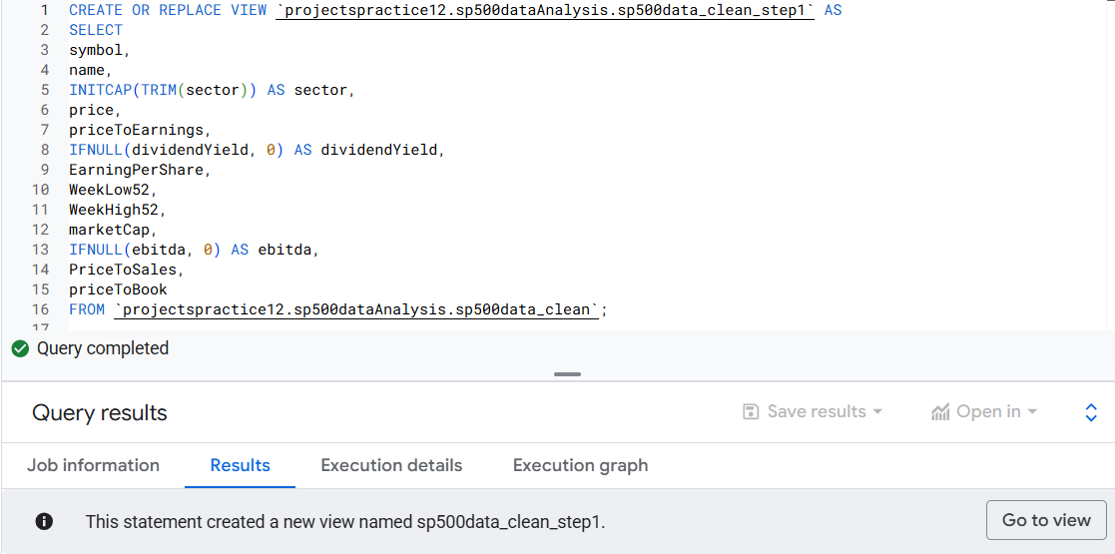

Reducing sector variation and dropping outliers above the upper_bound (Q3 + 1.5 * (Q3 - Q1) )
- Create view - sp500data_clean_step2 (Used CASE statement and wildcard (%) to group sectors)

CREATE OR REPLACE VIEW `projectspractice12.sp500dataAnalysis.sp500data_clean_step2` AS
WITH mapped AS (
SELECT
symbol,
name,
CASE
WHEN sector IS NULL OR TRIM(sector) = '' THEN 'Unclassified'
-- Real Estate
WHEN UPPER(sector) LIKE '%REIT%'
OR UPPER(sector) LIKE '%REAL ESTATE%'
THEN 'Real Estate'
-- Financials
WHEN UPPER(sector) LIKE '%BANK%'
OR UPPER(sector) LIKE '%INSUR%'
OR UPPER(sector) LIKE '%CAPITAL MARKET%'
OR UPPER(sector) LIKE '%FINAN%'
OR UPPER(sector) LIKE '%ASSET MANAGE%'
OR UPPER(sector) LIKE '%BROKER%'
THEN 'Financials'
-- Information Technology
WHEN UPPER(sector) LIKE '%SOFTWARE%' OR UPPER(sector) LIKE '%SEMICON%'
OR UPPER(sector) LIKE '%TECH%' OR UPPER(sector) LIKE '%HARDWARE%'
OR UPPER(sector) LIKE '%IT %' OR UPPER(sector) = 'IT'
OR UPPER(sector) LIKE '%DATA%' OR UPPER(sector) LIKE '%ELECTRONIC%'
THEN 'Information Technology'
-- Communication Services
WHEN UPPER(sector) LIKE '%TELECOM%'
OR UPPER(sector) LIKE '%COMMUNICAT%'
OR UPPER(sector) LIKE '%MEDIA%'
OR UPPER(sector) LIKE '%ENTERTAIN%'
OR UPPER(sector) LIKE '%INTERACTIVE%'
THEN 'Communication Services'
-- Health Care
WHEN UPPER(sector) LIKE '%HEALTH%' OR UPPER(sector) LIKE '%PHARM%'
OR UPPER(sector) LIKE '%BIOTECH%' OR UPPER(sector) LIKE '%MEDICAL%'
OR UPPER(sector) LIKE '%LIFE SCIENCE%'
THEN 'Health Care'
-- Consumer Staples
WHEN UPPER(sector) LIKE '%CONSUMER STAPLES%'
OR UPPER(sector) LIKE '%CONSUMER DEFENSIVE%'
OR UPPER(sector) LIKE '%FOOD%'
OR UPPER(sector) LIKE '%BEVERAGE%'
OR UPPER(sector) LIKE '%TOBACCO%'
OR UPPER(sector) LIKE '%HOUSEHOLD%'
OR UPPER(sector) LIKE '%PERSONAL PRODUCT%'
OR UPPER(sector) LIKE '%STAPLES RETAIL%'
THEN 'Consumer Staples'
-- Consumer
WHEN UPPER(sector) LIKE '%CONSUMER DISCRETIONARY%'
OR UPPER(sector) LIKE '%AUTOM%'
OR UPPER(sector) LIKE '%RETAIL%'
OR UPPER(sector) LIKE '%TEXTILE%'
OR UPPER(sector) LIKE '%APPAREL%'
OR UPPER(sector) LIKE '%LUXURY%'
OR UPPER(sector) LIKE '%HOTEL%'
OR UPPER(sector) LIKE '%RESTAURANT%'
OR UPPER(sector) LIKE '%LEISURE%'
OR UPPER(sector) LIKE '%E-COMMERCE%'
THEN 'Consumer'
-- Industrials
WHEN UPPER(sector) LIKE '%INDUSTR%'
OR UPPER(sector) LIKE '%AEROSPACE%'
OR UPPER(sector) LIKE '%DEFENSE%'
OR UPPER(sector) LIKE '%MACHIN%'
OR UPPER(sector) LIKE '%CONSTRUCTION%'
OR UPPER(sector) LIKE '%ENGINEER%'
OR UPPER(sector) LIKE '%TRANSPORT%'
OR UPPER(sector) LIKE '%LOGISTIC%'
OR UPPER(sector) LIKE '%COMMERCIAL SERVICES%'
THEN 'Industrials'
-- Materials
WHEN UPPER(sector) LIKE '%MATERIAL%'
OR UPPER(sector) LIKE '%CHEMIC%'
OR UPPER(sector) LIKE '%METAL%'
OR UPPER(sector) LIKE '%MINING%'
OR UPPER(sector) LIKE '%PAPER%'
OR UPPER(sector) LIKE '%FOREST%'
THEN 'Materials'
-- Energy
WHEN UPPER(sector) LIKE '%ENERGY%'
OR UPPER(sector) LIKE '%OIL%'
OR UPPER(sector) LIKE '%GAS%'
OR UPPER(sector) LIKE '%COAL%'
OR UPPER(sector) LIKE '%RENEWABLE%'
OR UPPER(sector) LIKE '%SOLAR%'
THEN 'Energy'
-- Utilities
WHEN UPPER(sector) LIKE '%UTILITY%'
OR UPPER(sector) LIKE '%ELECTRIC%'
OR UPPER(sector) LIKE '%WATER%'
OR UPPER(sector) LIKE '%POWER%'
OR UPPER(sector) LIKE '%GAS UTIL%'
THEN 'Utilities'
ELSE sector
END AS sector_std,
price,
priceToEarnings,
dividendYield,
EarningPerShare,
WeekLow52,
WeekHigh52,
marketCap,
ebitda,
PriceToSales,
priceToBook
FROM `projectspractice12.sp500dataAnalysis.sp500data_clean_step1`
)
SELECT
symbol,
name,
sector_std AS sector,
price,
priceToEarnings,
dividendYield,
EarningPerShare,
WeekLow52,
WeekHigh52,
marketCap,
ebitda,
PriceToSales,
priceToBook
FROM mapped
WHERE PriceToSales >= 0
AND PriceToSales <= 12.78
AND priceToEarnings >= 0
AND priceToEarnings <= 69.185;

